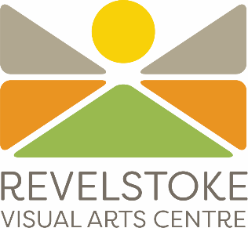

**Exhibition Application Form 2026***2026 Exhibition proposals must be received by midnight September 7, 2025*

*Submissions can be emailed to:*

***info@revelstokeartgallery.ca***

1. **Gallery Information**
2. **Application Part One |** Overall concept, written
3. **Application Part Two |** Examples of previous work
4. **Floor Plan**
5. **Exhibition Information**
6. **What happens next?**
7. **Signatures |** Signature Required

**GALLERY INFORMATION**

We’re proud to do things a little differently at the Revelstoke Visual Arts Centre. Here’s a little bit more about us, so you can decide if our gallery is the right fit for you.

* The Revelstoke Visual Arts Centre is Revelstokes only community gallery. Revelstoke is a popular tourist destination throughout the year and is quickly gaining a reputation for being a bustling artist community.
* Our non-profit centre hosts four exhibition spaces as well as private artist studios, a pottery studio, woodshop, and public workshops.
* RVAC openings are well attended by a diverse range of community members and visitors. These opening events are a chance to meet the artists, enjoy refreshments and listen to live music.
* We are fortunate to have an engaged community of artists, viewers, and collectors.
* The Revelstoke Visual Arts Centre is determined to provide a genuinely supportive and welcoming environment for artists and visitors alike. While we maintain a strong level of professionalism and presentation we do not reinforce the exclusivity often found in the art world.
* The art presented within our gallery represents a diverse range of mediums and themes.
* RVAC is a queer friendly space and we welcome artists with diverse backgrounds.
* This application form is for solo artists, or small groups looking to exhibit their work in our 2026 exhibition season (April 2026 - February 2027)
* Chosen artists will have their work displayed for roughly six weeks.
* Artists set their own prices, however guidance can be provided upon request. Artists may also choose to mark their work as “Not For Sale”.

**Application costs**

Each submission will incur a $25 application fee. This goes towards our curation and exhibition expenses. Our team will send an invoice for this application fee in September.

**Who Can Apply?**

* Applications are open to everyone! The Revelstoke Visual Arts Centre prides itself on exhibiting a diverse mix of artwork from a diverse range of artists.
* Local, regional, national, and international applications are welcome.
* All mediums welcome, including installations, sculpture, audiovisual, e.c.t.
* *Please note:* Artists who exhibited with us in 2025 are not eligible to exhibit again in 2026. As a policy an artist cannot have an exhibition two years in a row. However they may be eligible for the January and February 2027 slots (included in this exhibition season).
* Your artwork should be new or recent work that has not been shown before in Revelstoke.
* The entire body of work does not have to be complete when applying for an exhibition

**Artist Fees**  
The Revelstoke Visual Arts Centre offers an alternative model for compensating our artists. Unfortunately we are unable to pay CARFAC / artist’s fees at this time. In lieu of artist fees we provide a reduced commission rate on all gallery and gift shop sales, with 80% to the artist and 20% to the gallery. RVAC also provides additional support to our artists and covers all costs associated with the installation, marketing, and opening of an exhibition. Please see below for a list of services offered.

While we cannot currently pay artist fees, we can help you with letters of support for grant applications. Please contact us if you are interested in seeking out funding and granting opportunities.

We recognise that this alternative compensation model may not work for all artists. Please contact us if you have any questions or concerns, we aim to be transparent throughout the entire exhibition process, including payouts.

Our full Exhibition Policy can be sent on request, and all successful applicants will be sent a copy prior to their show.

**Exhibition Support and Services**

Services the Revelstoke Visual Arts Centre provides, free of charge:

* Marketing each exhibition through email, print, and social media
* Additional radio advertising provided for select shows
* Exhibition opening event expenses including bartending, staffing, and live music
* Curation and/ or curatorial suggestions for each exhibition
* Packaging work with the artists during takedown - using the original packing materials
* Communication with potential buyers, including locally, nationally and internationally
* Packaging and shipping items that sell during the show - shipping is at the buyers expense
* All POS transactions and system fees are covered by RVAC

**Accessibility and Chronic Illness**

The Revelstoke Visual Arts Centre has a long history of hosting artists with varying accessibility needs. We recognise that everyone has different energy levels, abilities and needs and we’re happy to make accommodations. If your exhibition is selected, please notify our staff of any accessibility needs or boundaries you may have. We’re here to accommodate without judgment.

Our staff members know a small range of ASL and are happy to host artists who are Deaf and hard of hearing.

**Helpful Hints!**

* We want to see that you’ve put thought into your exhibition - show us you’ve thought about the finished product! We encourage diagrams if that helps to illustrate your concept. Use photos that highlight what we will see in your proposed show.
* When writing your exhibition theme, or purpose behind the show, we are looking for a clear idea of your show rather than eloquent language. A concise elevator pitch will get your idea through to our committee best.
* Although not mandatory RVAC encourages multi disciplinary components such as; sound, video, installation, sculpture, performance, etc. Think outside the box and have fun with it.
* We understand that your proposed exhibition may not be complete when applying. We also understand that your work may evolve and change as you create the pieces. Therefore we accept examples of your previous work. Photo examples should be as close to the proposed show as possible.

**APPLICATION PART ONE | OVERALL CONCEPT**

If the proposal is for a group exhibition, please provide one main contact and then provide details for all the artists participating within the exhibition.

If you require extra assistance to complete this application, please email us at *info@revelstokeartgallery.ca* and we will be happy to assist you.

| **Name (First, Last)** | | | |
| --- | --- | --- | --- |
| **Artist name if different from above** | | | |
| **City** | | | |
| **Phone ( )** | **Email** | | |
| **Exhibition Title** *If you are uncertain of your title please write TBD.* | | | |
| **Quick Overview/ Theme of Exhibition** *Please in 1 - 2 sentences, describe the theme of your proposed exhibition. (50 words max)* | | | |
| **Artist Bio** *Please include an artist bio (150 words max), submitting a CV/resume is highly encouraged but not mandatory.* | | | |
| **Relevant Medium(s) & Techniques** *(50 words max)* | | | |
| **What is the purpose and/or concept of your show? What are you hoping viewers take away from your show? This is where you can expand on the theme of your exhibition.** *(200 words max)* | | | |
| **Why do you want to exhibit at the Revelstoke Visual Arts Centre?** *(150 words max)* | | | |
| **How will your artwork be displayed/ presented?** *Please give an idea of the final presentation. Include any special install or hanging requirements if applicable.* | | | |
| **Number of works** *Approximately* | | **Size range of your pieces** *Approximately* | |
| **Preferred gallery** *Main, or Side Gallery 1, 2 or 3* | | | |
| **Preferred exhibiting month(s)** *We make an effort to accommodate this but cannot guarantee preferences. Exhibition schedule April 2026 - February 2027* | | | |
| **Website/Facebook/Instagram** *Not mandatory, but encouraged* | | | |
| **If your application is not selected for a solo exhibition, would you be interested in joining one of our curated group shows?** *This will not affect your solo exhibition application.* | | | |
| **How did you hear about our public art gallery?** | | | |

**APPLICATION PART TWO | EXAMPLES OF PREVIOUS WORK**

* Please include 5 - 10 individual images of your recent/relevant artwork.
* Applications will not be returned. Do not mail original works of art.
* Images can be included at the end of this document, or emailed as attachments: info@revelstokeartgallery.ca
* If your images are too large please contact us and we can provide a Google Drive folder for upload.
* If you are submitting audio or video you may:
  + Include a link to vimeo, youtube, soundcloud, e.c.t
  + Email these files as attachments
  + Request a google drive folder for upload
* If you are including a diagram, please include it in this section
* If you require technical assistance please contact our team
* 2026 Exhibition proposals must be received by midnight September 7, 2025
* Late submissions will not be accepted

Completed applications can be emailed to [info@revelstokeartgallery.ca](mailto:info@revelstokeartgallery.ca)

**Helpful Hints!**

* High quality photos are important. Please make sure your images are well lit, infocus, and large enough for our selection committee to zoom in.
* If there are unique elements fundamental to your work please feel free to highlight them with behind a behind the scenes photo or close up.
* It’s best to highlight your strongest and most recent work. Don’t feel like you need to include every piece you’ve ever made.

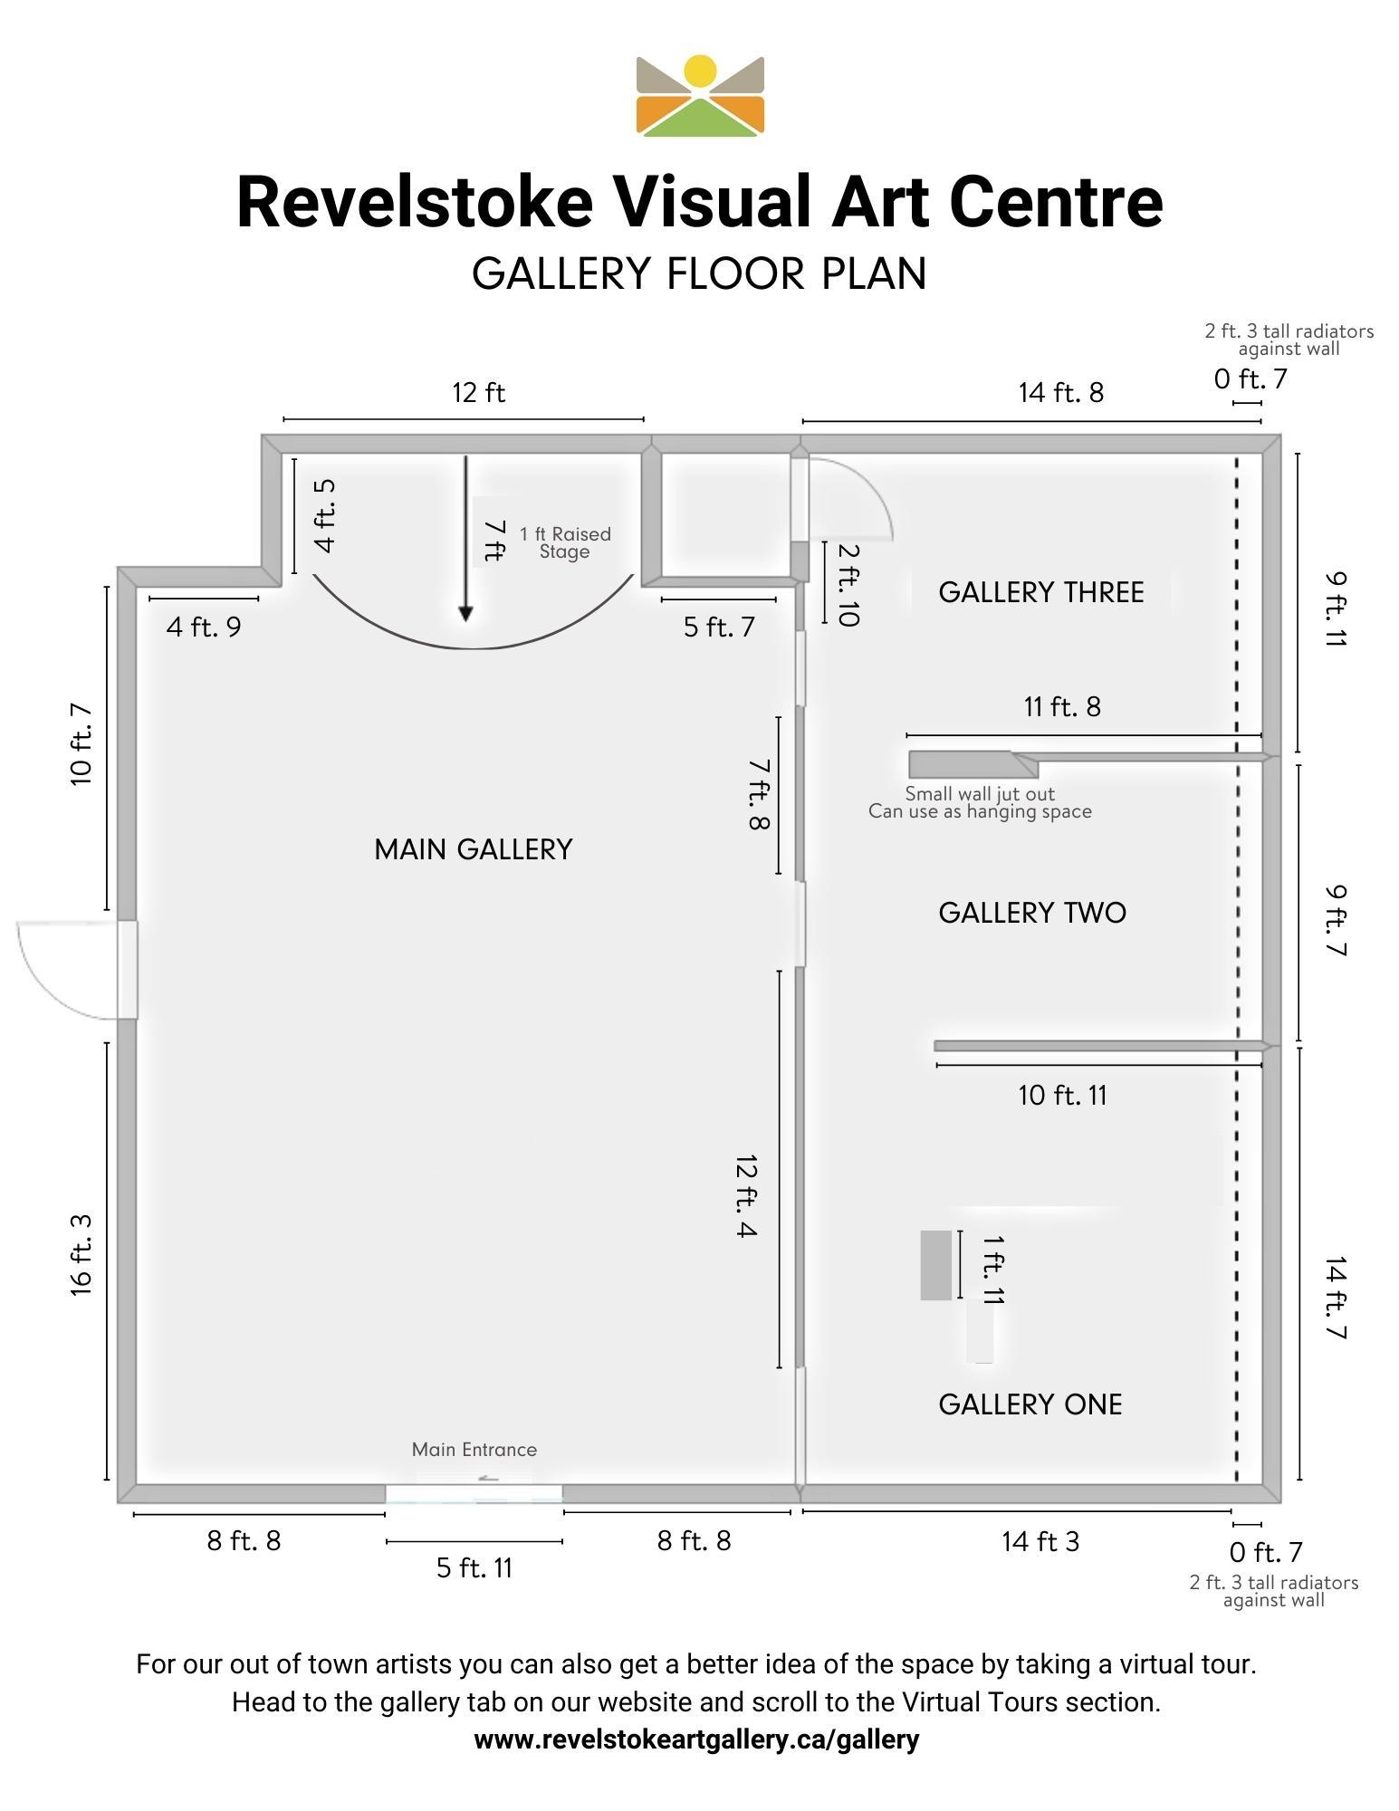

**EXHIBITION INFORMATION**

**The Galleries**

The Revelstoke Visual Arts Centre has four exhibition spaces, our main gallery and three adjacent side galleries. In the past we have allocated more than one side gallery space to one solo artist if requested or as we see fit.

Main Gallery:

Floor Area: 23 x 30 feet

Gallery Height: 11 feet

Side Gallery 1:

Floor Area: 15 x 15 feet

Gallery Height: 8 feet

Side Gallery 2:

Floor Area: 15 x 9 feet

Gallery Height: 8 feet

Side Gallery 3

Floor Area: 14 x10 feet

Gallery Height: 8 feet

**Gallery Security**  
The Revelstoke Visual Arts Centre has an alarm system. The galleries are always monitored when open, and when they are closed the alarm system is engaged. The curator room alarm system is also engaged between shows. Only gallery staff have access to this alarm system.

**Hanging the Exhibition**

The artist will be responsible for delivering the work to the gallery and collecting the work at pre-arranged dates. The artist is highly encouraged to take part in the hanging and taking down of the exhibition with the gallery staff and hanging committee.

Work must be appropriately framed or mounted and ready for hanging with instructions where special treatment is required. The gallery is able to loan some metal exhibition frames. Artists are responsible for framing the work and providing mats.

**Original Work**

All work must be original and must be the artist's own work. No prints/copies of originals (unless discussed with the Executive Director & Exhibition Committee) We accept digital illustrations and encourage further discussion about originals.   
  
Please be aware that copyright laws are extensive and prohibit the incorporation or copying of the work of other artists, designers or craftspeople without prior permission. Credit must be given for any contribution by another artist or artists to the work.

Your work should be new work or recent work that has not been shown before in Revelstoke.

*We are accepting Exhibition Proposals for the 2026 exhibition season from*

***July 1st, 2025 to September 7, 2025***

*Late submissions will not be accepted*

**WHAT HAPPENS NEXT?**

**Application Review**

All applications are reviewed by our exhibition committee - a group of artists, photographers and educators. These community members have experience curating classic gallery shows as well as eclectic and alternative exhibitions. The final decision, aided by the exhibition committee, comes down to our Executive Director.

Any further questions can be directed to our gallery administrator: [info@revelstokeartgallery.ca](mailto:info@revelstokeartgallery.ca)

**Application Fee**

Our team will send invoices for the $25 application fee in rounds. This will likely happen in mid to late September. Please do not be alarmed if your invoice is not sent at the time of submission.

**Notification of results**

We appreciate how much time and energy it takes to apply for an exhibition. Our Executive Director will notify you no matter the results of your application. These notifications will likely be sent early November.

Unfortunately RVAC does not have the capacity to send personalised feedback at this time.

**Further information**

If your application is successful our staff will contact you with a contract and exhibition package with more information.

**Accessibility and chronic illness**

We recognise that everyone has different energy levels, abilities and needs and we’re happy to make accommodations. If your exhibition is selected, please notify our staff of any accessibility needs or boundaries you may have. We’re here to accommodate without judgment.

**SIGNATURES**

By signing this agreement I, __________________________________ agree that the application I have submitted consists solely of my own work and that I have not replicated images or concepts by another artist without their permission.

Name of Exhibitor, (First, Last) ________________________________________________________  
Signature _______________________________________________

Date (dd/mm/yyyy) ______________________________________